AJAY KUMAR
E-Mail: ajay.ary05@yahoo.co.in
Contact: +91 9899073085/7065812128
Local Address: Flat No 101, Plot No. C 31/32, Vill- YusufPur Chak saberi, Sri Sai Upvan Society, Noida UP

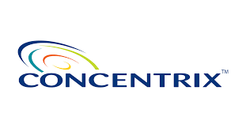
In quest of challenging assignments in Computer Science and Engineering with an organization of repute.

Current Employee- Concentrix Daksh Services India Private Limited (Concentrix)
Sr. Software Engineer
Key Skill – Asp.net, C#, Asp.net MVC, .Net Core, Web API, .Net Core, Entity Framework,
Micro Services, Sql Server, Oracle, SignalR, Github, Agile Methology, Jira, Jquery.
Period- 28-April-2021 to Till Date
Responsibility & Roles - Coding, Designing and Unit Testing. Also involve in
Deployment and Product Support.
Address-
26, DLF Tower 8th Rd, DLF Cyber City,
DLF Phase 2, Sector 24, Gurugram,
Haryana 122002.

Synopsis

- Having 11 Years of Works expérience as a Senior Software Engineer in Dot Net Technical Domain.
- Acquired reliable knowledge and Good command over C#, ASP.NET, ADO.NET, Asp.net MVC,
SQL Server 2005/08/12/14, Java Script, Ajax Tool Kit, Entity Framework , jQuery, Oracle Database, Web Api, .NET Core , Basic knowledge of react js, Micro Services, Json.
- Project Experience of Asp.net, SQL , Entity Framwork, Linq, Mvc 4.0 , Jquery ,Json, Oracle database,
.Net Core, SSRS Reports, Web API, Knockout JS, JSON, SQL Server, SignalR
- Work with third party tool for report report generation in Word and excel ASPOSE and also integrate third
party service (Amazon S3 Service) with our application.
- Ability to Works within Tight Deadlines, Self-Motivator and a Team Player.
- Good Analytical Skills and Team Spirit.
- A keen communicator with dynamic relationship building, analytical & problem solving abilities.

ADDITIONAL KEY SKILLS -
- Basics of business domain to understand the business requirements.
- Analytical abilities, Strong Technical Skills, Good communication skills.
- Good understanding of the technology and domain.
- Knowledge of Agile methodologies, Jira, Sonarqube.

Academia

- B.Tech in Computer Science And Engineering from Dr. K.N. Modi Institute of Engineering & Technology
Modi Nagar, affiliated to UP Technical University, Lucknow, Uttar Pradesh in 2009.
- XII from Sachidanand Inter College Captanganj approved by U.P. Board in 2005.
- X from Sachidanand Inter College Captanganj approved by U.P. Board in 2003.

Industrial Training

Organisation: DUCAT
Description:
- Undergone 6th Month Project Training on .Net 2008 3.5 Framework Which Include
- the following topics:
  - C#.NET
  - ADO.NET
  - ASP.NET
  - SQL 2005
  - CRYSTAL REPORT
  - WEB SERVICES

Experience Details

Concentrix May 2021 –Till Now
Name of Employer : Concentrix
Date of Employment : 30 April 2021
Job Title : Sr. Software Engineer

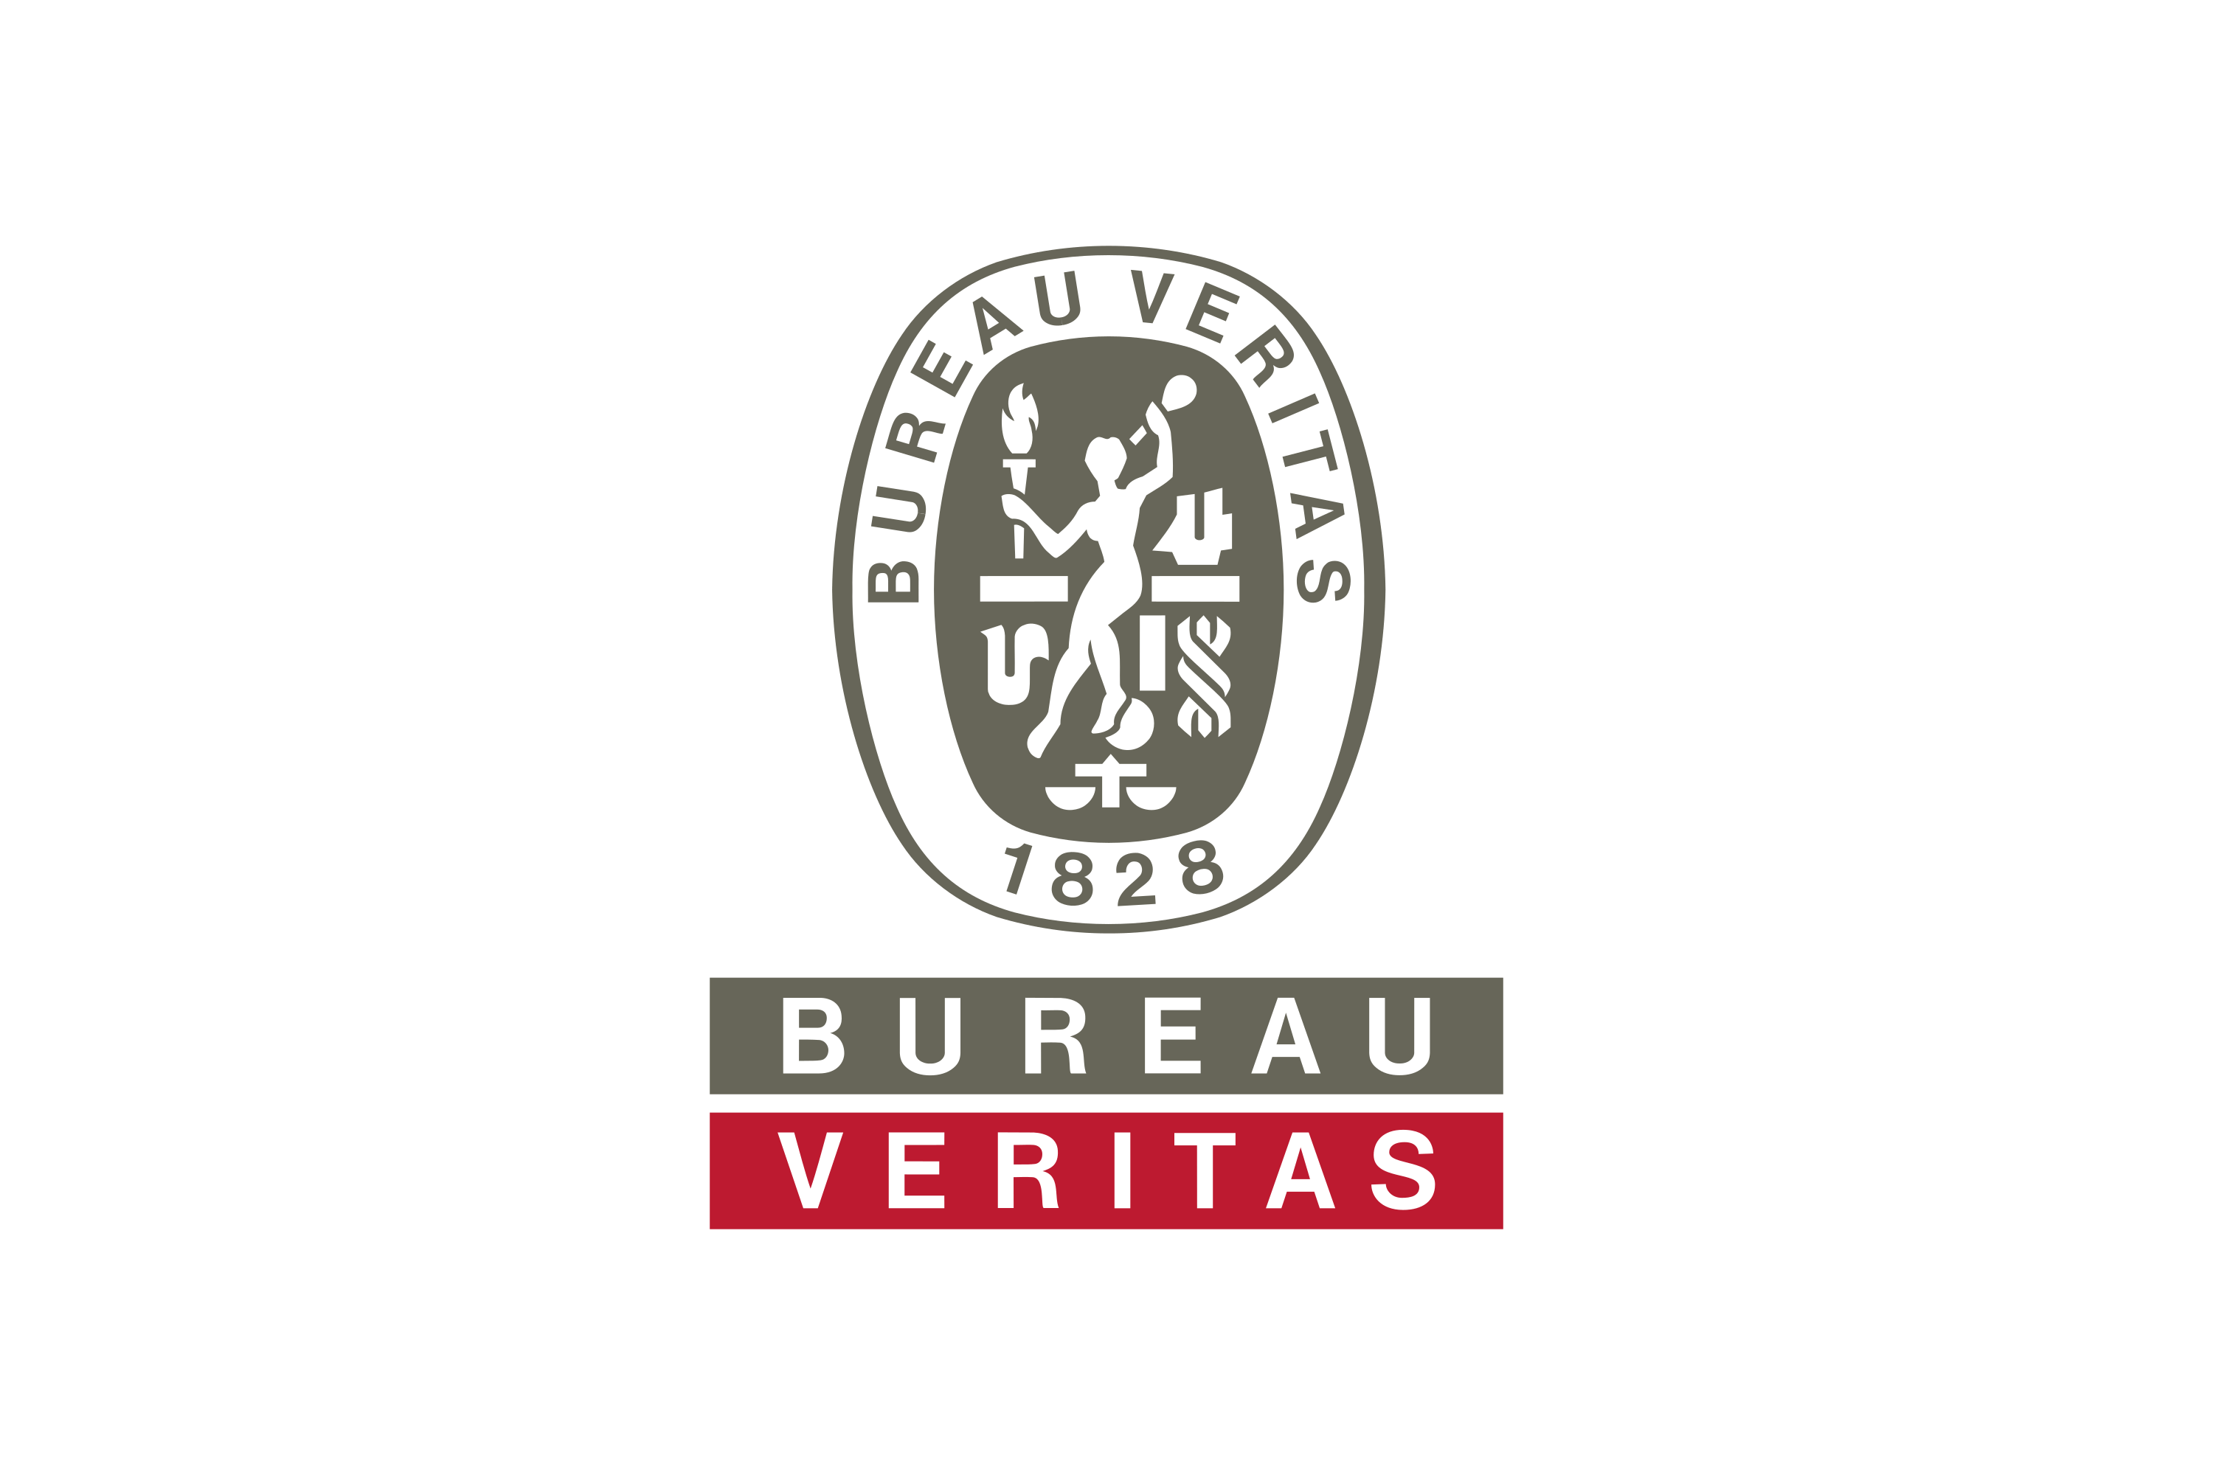
Bureau Veritas April 2020 – April 2021
Name of Employer : Bureau Veritas
Date of Employment : April 2020
Job Title : Sr. .net Developer



Indiabulls Housing Finance Ltd. Nov 2016 –March 2020
Name of Employer : Indiabulls Housing Finance Ltd.
Date of Employment : November 2016
Job Title : Sr. Software Engineer

Modern Testing Services April 2014 – Oct 2016
Name of Employer : Modern Testing Services (India) Pvt. Ltd.
Date of Employment : April 2014
Job Title : Software Engineer


Sms Deals Inc. February 2012 – April 2014
Name of Employer : Sms Deals Inc.
Date of Employment : February 2012
Job Title : Software Developer


Mascot Business Solution August 2011 – February 2012
Name of Employer : Mascot Business Solution
Date of Employment : May 2011
Job Title : (Software Trainee)

Project Details

April/2020 – April /2021 BVOneTrade (Lab Information Management System)

Project Descriptions

Project developed to maintain the Lab information management system which includes information regarding the product testing and quality assurance and certification. This system specially build for job creation, sample testing, report generation and billing to the clients.
There is lots of reports which is developed using SSRS reports and front side RDLC reports.

Organization : Bureau Veritas Consumer Product Pvt. Ltd.
Contribution : Work requirements analysis and coordination with the client.
Designing Views and Model Classes, Coding and Database. Stored Procedures

Technologies used: .NET Framework 4.8, MVC .Net Core 3.1, J query, Json, C#.Net, Sql Server 2014,
Ajax Tool Kit, HTML, Java Script, Smart Admin.

Team Size : 5

September/2018 – December 2020 Galaxy Application (CIBIL/HUNTER) AND DISHA APPLICATION

Project Descriptions

This is the combine module of cibil application and hunter application with disha API.
Cibil application is for pulling the cibil of customer through the services provided by Transunion.
We get the data from Trans Union and we create the Report on run time and generate the PDF report and send back to galaxy application and Dynamic Crm through API provided by CRM or ESB which is the interface service provider to Microsoft dynamics.

Organization : Indiabulls housing Finance Limited
Contribution : Work requirements analysis and coordination with the client.
Designing forms, Coding and Database. Stored Procedures

Technologies used: .NET Framework 4.5, MVC 4.0, Jquery, Json, Aspose, C#.Net, Oracle,
Ajax Tool Kit, HTML, Java Script
Team Size : 3
October/2016 - August 2018 DEDUPE Application (DEDUPLIX)

Project Descriptions

Dedupe application is the project to find out the duplicate application punched on the same time or exiting customer in our existing database. This application have 4 modules.
- Client id generation
2- Property Id generation.
3 - Group Id generation
4 - Exposure Report

There is some defined parameter on which we generate the cif id of customer like Their PAN Number, Voter Id,
Passport, Driving License, Name data of Birth and Father Name, GST etc.
We also give the match result on address, mobile number, employer name, Bank name and account name etc. these are the probable match.
User can check the matched result on screen and do the making positive of negative on the basis of match result from the existing database which have the collection of data from different-different sources.

After the marking, we generate the PDF Report of that application no.

In the same way we generate property id, group is on some specified parameters and on the basis of existing client id, group id and some business logic, we generate the exposure report of the particular application.

Organization : Indiabulls housing Finance Limited
Contribution : Work requirements analysis and coordination with the client.
Designing forms, Coding and Database. Stored Procedures

Technologies used: .NET Framework 4.5, MVC 4.0, Jquery, Json, Aspose, C#.Net, Oracle,
Ajax Tool Kit, HTML, Java Script
Team Size : 2

November/2015 –August 2016 SOFIA (System of Inspection and Audit)

Project Descriptions

SOFIA (system of inspection and audit) is an Application which provides a solution for Working personal
managements and resource assignments for different division and works. There travelling cost calculation, salary
calculation, Work load matrix, Protocol Creation.
Admin and HR have the power to create different-different divisions Mangers And their staff.
And give him the permission to Add, Edit and delete the records. It’s a solution to govern the resources from a
single and compact way.

Organization : Modern Testing Services (India) Pvt. Ltd
Contribution : Work requirements analysis and coordination with the client.
Designing forms, Coding and Database. Stored Procedures

Technologies used: .NET Framework 4.5, MVC 4.0, Jquery, Json, Aspose, C#.Net, SQL Server 2012,
Ajax Tool Kit, HTML, Entity Framework, Java Script
Team Size : 4 including Designer

URL: http://14.140.163.70:201

November/2014 – October 2015 LIMS (WEB APLLICATION)

Project Descriptions

LIMS (Lab Information Management System) is ERP Application. It’s provides a powerful suites of solution for
inspection and testing control, data management for multiple location. It’s provide fully user control menu to
modify TRF(Test Request Form), reporting, invoicing through admin panel Where client can check & download
their Testing & inspection reports using their user id & password. Some selected clients can also download/ upload TRF & other important documents like Package, Protocol sheets. All invoices and report made in ASPOSE WORDS
(Third party Tool). Search data entry by a user in a particular date, sample number, Client, vendor, Factory and
Lab. User can test assign, resource allocation, status, sample tracking and label printing.

Organization : Modern Testing Services (India) Pvt. Ltd
Contribution : Work requirements analysis and coordination with the client.
Designing forms, Coding and Database. Stored Procedures

Technologies used: .NET Framework 4.5, C#.Net, SQL Server 2012, JavaScript,
Ajax Tool Kit, HTML, Entity Framework
Team Size : 4 including Designer

URL: http://ebs.mts-global.com:8080/

04/2014 – 10/2014 MTS i-Solution (Web)

Project Descriptions

Critical decision-making and effective day-to-day management of multi-stage product evolution life cycles
requires immediate access to critical data and information. i- Solution is a wholly-integrated platform designed
to meet those needs by providing a single unified view of your supply chain's quality management activities
globally.

Organization : Modern Testing Services (India) Pvt. Ltd
Contribution : Work requirements analysis and coordination with the client.
Designing forms, Coding and Database. Stored Procedures

Technologies used: .NET Framework 3.5, C#.Net, SQL Server 2010, JavaScript,
Ajax Tool Kit, HTML
Team Size : 3
URL : http://online.mts-global.com/i-solution/

08/2013 – Till Date Vartex CRM

Project Descriptions

This Vartex CRM Project entails all aspects of interaction that a company has with its customer,
Whether it is sales or service-related.

AUTO SMS NOTIFICATION for
- Warranty Expires and Service Renewals
- Complain and Resolved
- Payment pending or done etc.

The admin centric element include following service components: -
- Create, assign and manage requests made by customers.
- Search for their customers and products with full details.
- Download Monthly service(Free/Paid) report

The customer centric element include following service components: -
- Paid Service
- Free Service
- Complains
- Take Service in future.

Contribution
- Coding, database designing and implementing business logics
- Work requirements analysis and coordination with the client.
- Working on all modules of project.

Technologies used: .NET Framework 3.5, C#, SQL Server 2008, JavaScript,
Ajax Tool Kit, HTML
Team Size : 3 (including designer)
URL : http://vartexro.com

02/2013 – 05/2013 Dow Sms Event (Rajatech Sammelan)

Description of the Project:
This is a web based solution for sms event. In this application user send the sms through his mobile As DOW <space> 4-5 digits code to a long code 9664161616. If the sending code is valid then he will get 100 points. On every valid Code he will make 100 points. User will be identified by his mobile numbers Registered with us. If any user who is not registered then they have to send the DOW <space>Register <Space><User Name> to 64161616 to register himself via mobile. Through admin panel admin can view The all Responses came from users at any time. He can also view the Highest Scored till date time.
At the end of this event a user who made the maximum points, announced as winner of the event and he
Will get the prize.

Team Size: 2
Technologies used: .NET Framework 3.5, C#.NET, Ajax Tool Kit, ASP.NET, ADO.NET,
SQL Server 2005/08, JavaScript.
URL: http://www.smsevent.in/

02/2012 – 07/2012 Perfect Bulk Sms (Bulk Sms Services)

Description of the Project:
This is a web based solution for sending bulk of sms on a single click. In this application user can Create groups and manage them. For import contact numbers in a group there are different ways either Using csv or from text file. It allows user to send single & bulk sms or schedule sms with his desire Approved sender id. User can be either client or reseller. Reseller can create new users under his down Line. Reseller can add or Remove sms.
A user can view sms-history, transaction details of his & clients Under his downline. It even allows user to send messages from excel using excel-plugin tool.

Team Size: 2
Technologies used: .NET Framework 3.5, C#.NET, Ajax Tool Kit, ASP.NET, ADO.NET, CRYSTAL REPORT,
SQL Server 2005/2008, JavaScript.

Roles & Responsibilities:
- Implementation of front end design.
- Work on to implement Business logic.
- Work on Data Base.
- Managing Hosting for site and communicate with Server Team for any server issues.

URL: www.perfectbulksms.com/

Knowledge Purview

Technology Experience:

- .NET 2008/2013 3.5, 4.8, 5.0 FRAMEWORK, .NET CORE
- C#.NET, ASP.NET,ASP.net MVC, ADO.NET,LINQ
- SQL 2005/2008/2012
- MySQL
- CORE JAVA,JAVA SCRIPT
- CRYSTAL REPORT
- AJAX TOOL KIT
- MVC 4.0 , ENTITY FRAMEWORK , JQuery, Knockout JS
- .net Core , Basic of React JS

Technical Skills:

- .NET 2.0, 3.5,4.0,4.8, .net Core
- Language - C#, XML,C++
- Environment /Technology - ASP.NET, Web Services, Entity Framework
- Framework – Visual Studio 2008,2010/2013
- Database – SQL Server, MySql, Oracle database
- Tools – Jira, Bitbucket, Agile Mythology

Extra Curricular Activities

- Get certificate of Scout & Guide (A&B) in school Level.
- Active member of Student Placement Cell for two years.
- Event (MUSICIA) organizer in inter college youth fest AAHVAAHAN'07.
- Participating in inter college youth fest AAHVAAHAN07.

Hobbies

- Writing Poem, Surfing net.
- Listening to music, playing computer games.

Awards & Achievements

- Runner up in Aahvaahan’07” in Inter College Youth Festival.
- Winner in Paper Presentation Aahvaahan’07” in Inter College Youth Festival.
- Won the “Man of the Match” in Cricket in Class 12th.

Personal Dossier

Name - Ajay Kumar
Father’s Name - Mr. Sheshmuni Prasad
Mother’s Name - Mrs. Jyoti Devi
Date of Birth - 8th June 1988
Sex - Male
Marital Status - Married
Nationality - Indian
Language Known - Hindi, English
Permanent Address - Vill- Baulia, Post-Captanganj, Distt- Kushinagar -274301 (u.p.)
Current Address - Sai Upvan Society c, YusufPur Chak Saberi, Near gaur City,
Greater Noida west, Uttar Pradesh, 201309

